Git Challenge
Resolve Merge Conflicts
Create a merge conflict intentionally (two users editing the same line)
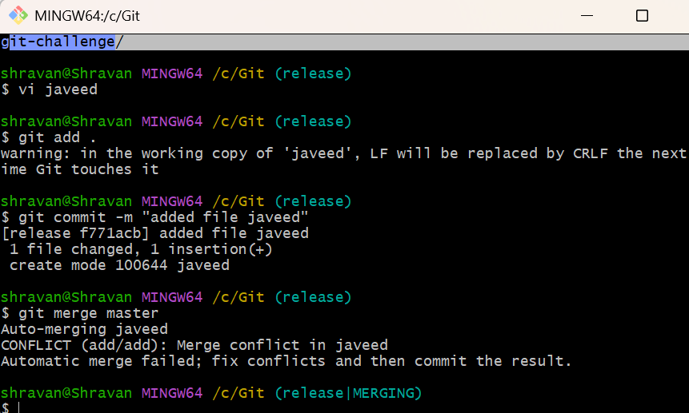
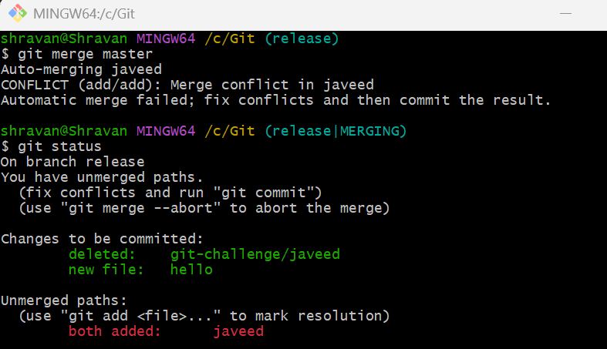
Resolve the conflict and push the changes.
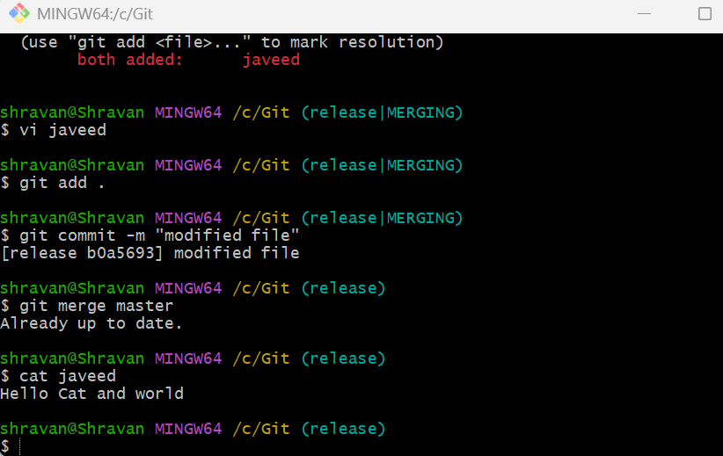
Recover Deleted Branch
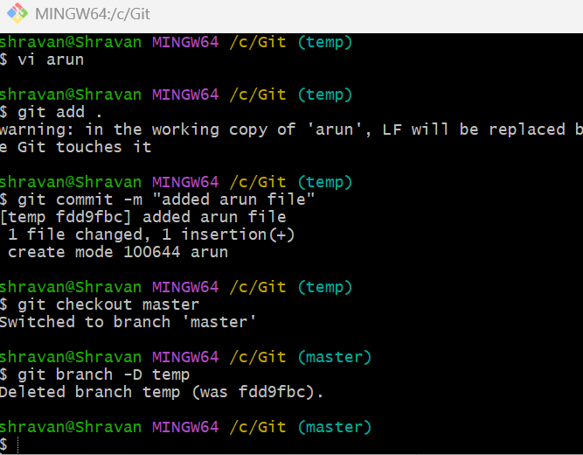
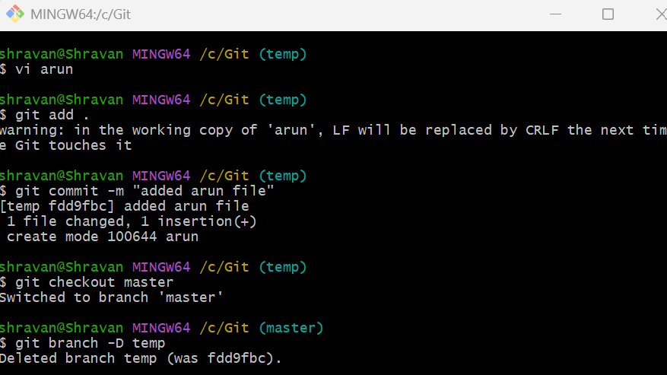
Delete a local branch and then recover it using the reflog.
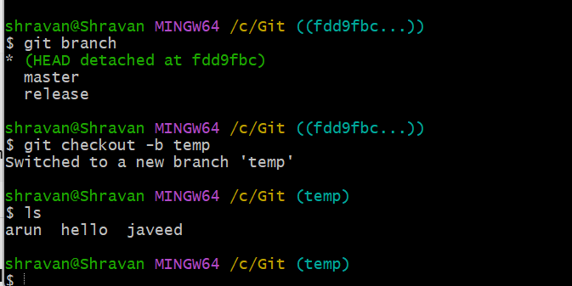
Undo Wrong Push
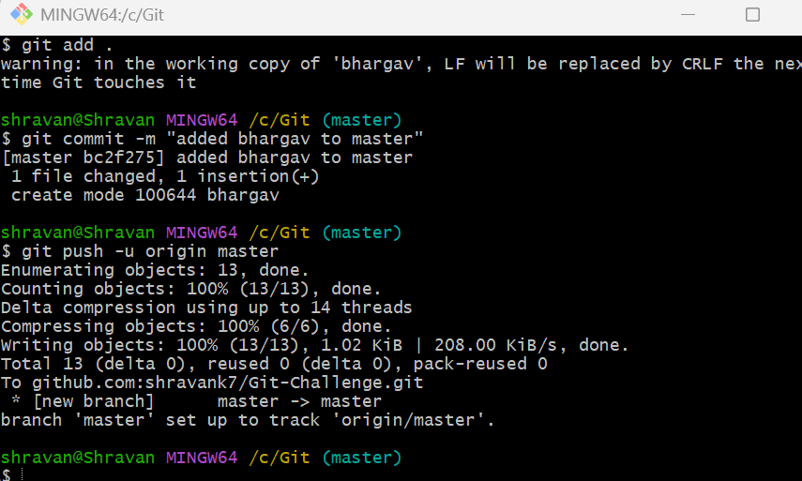
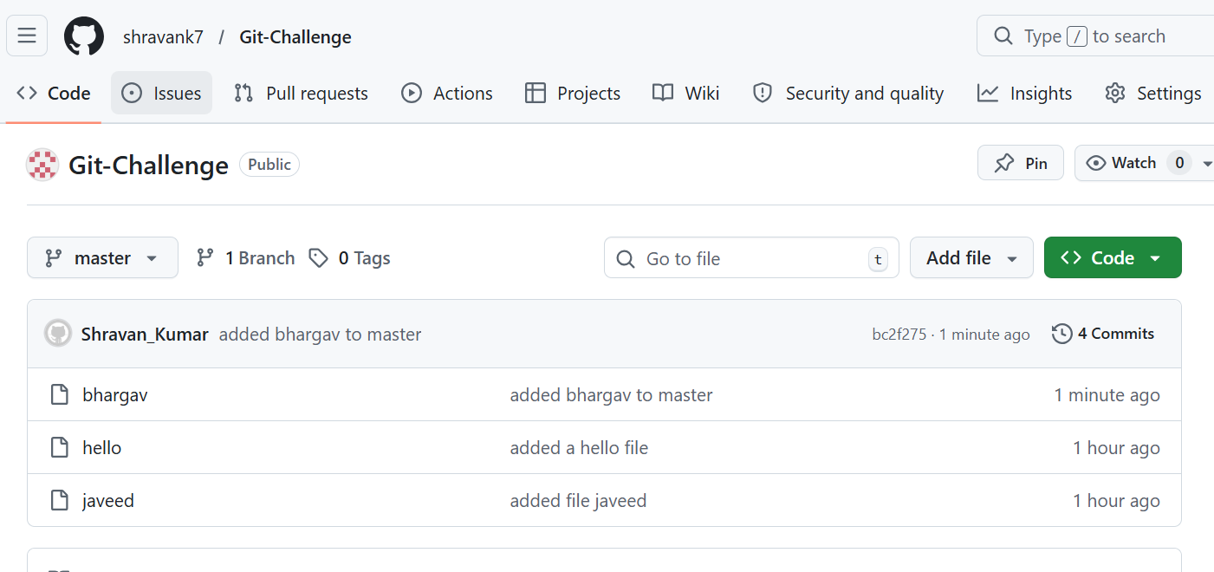
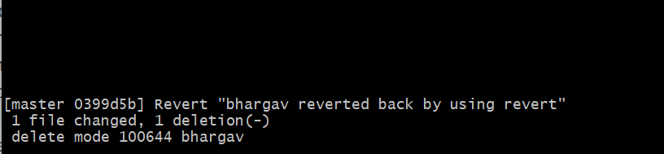
Push a wrong commit to GitHub, then undo it without losing history
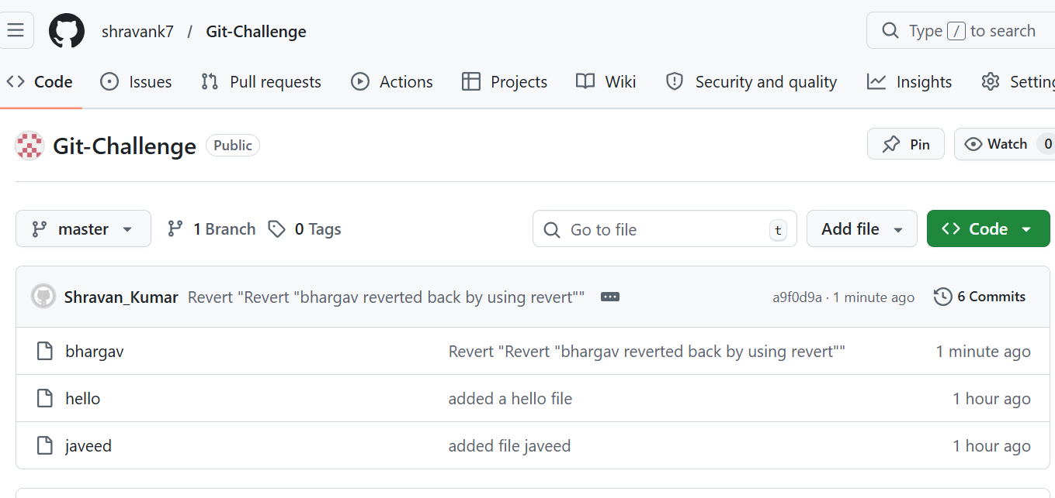
Amend a Commit
Make a commit, then add a missing file to it using git commit --amend.
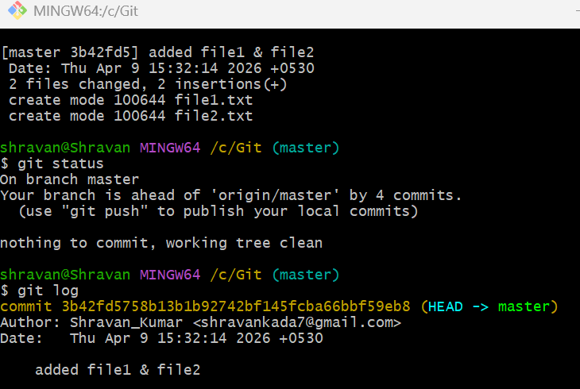
Cherry-pick a Commit
Take a specific commit from one branch and apply it to another branch.
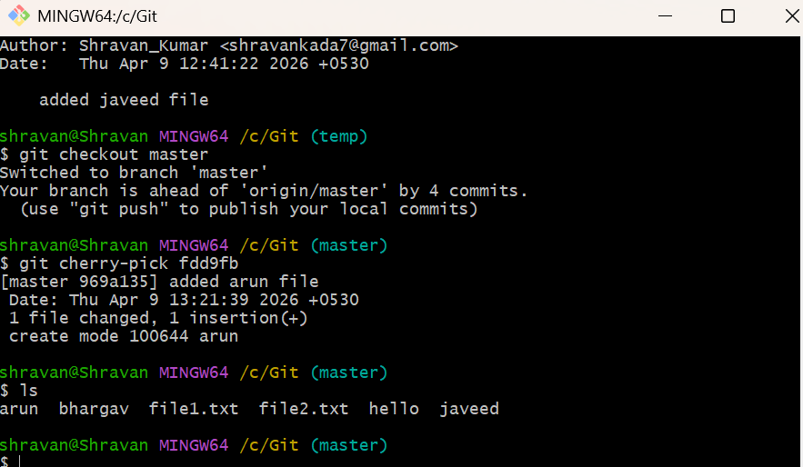
Interactive Rebase
Reorder and squash multiple commits into a single clean commit
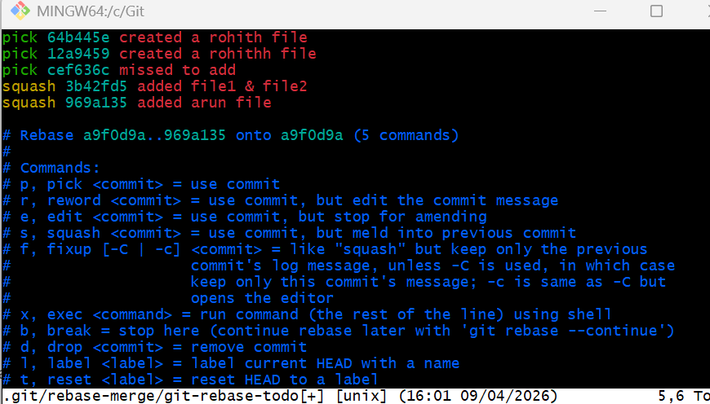
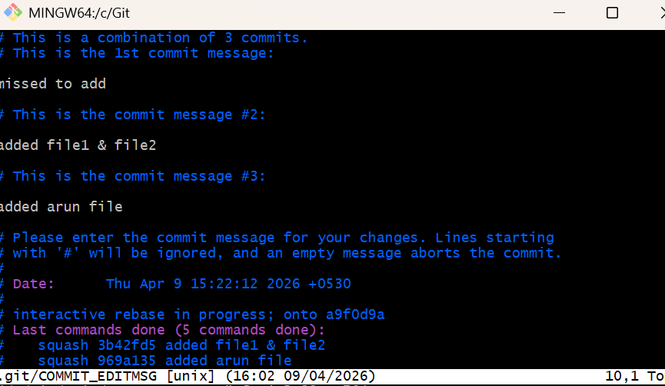
Tagging & Release
Create a version tag (v1.0), push it to GitHub, then delete and restore it
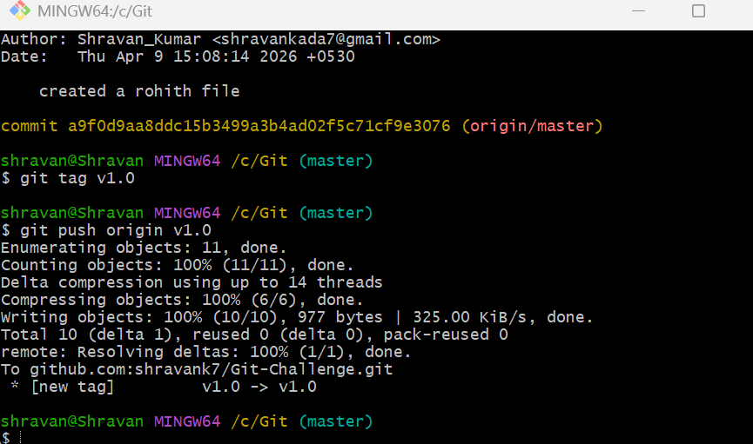
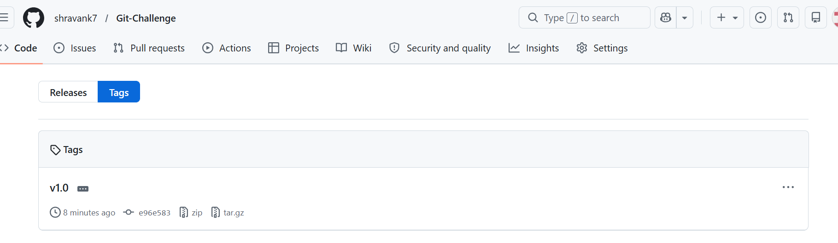
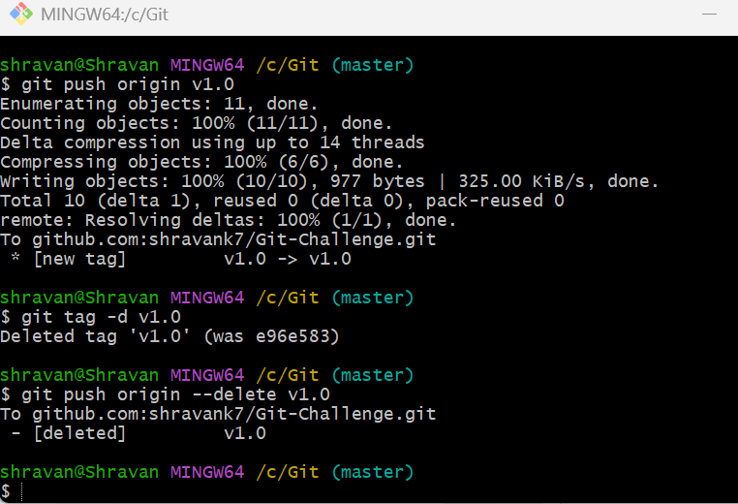
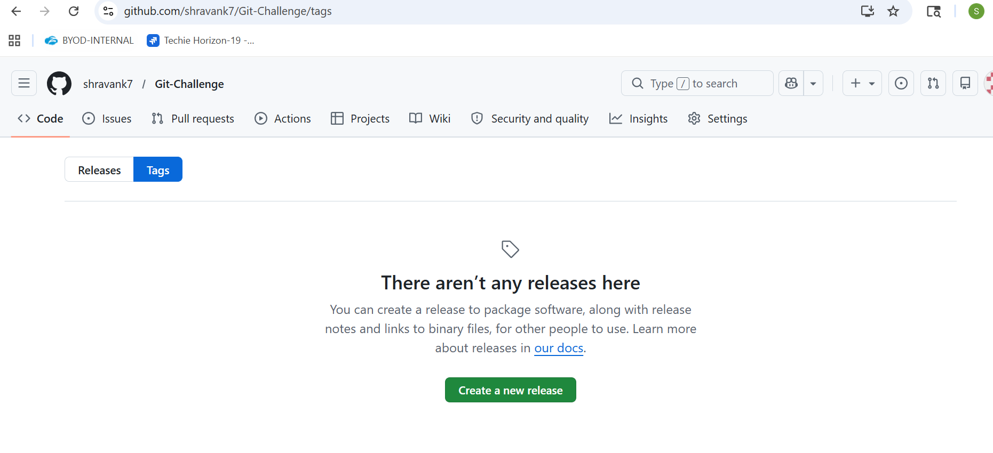
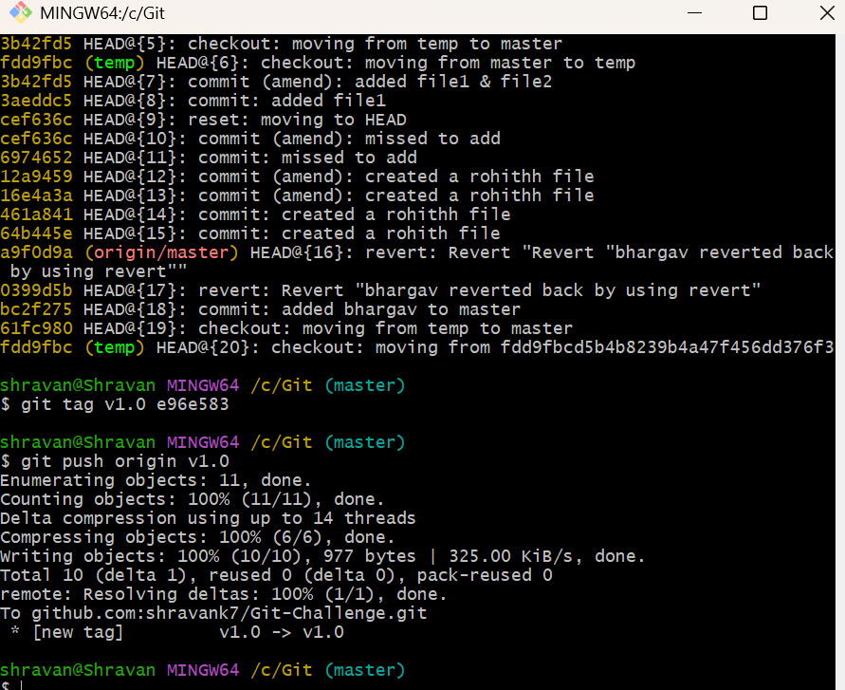
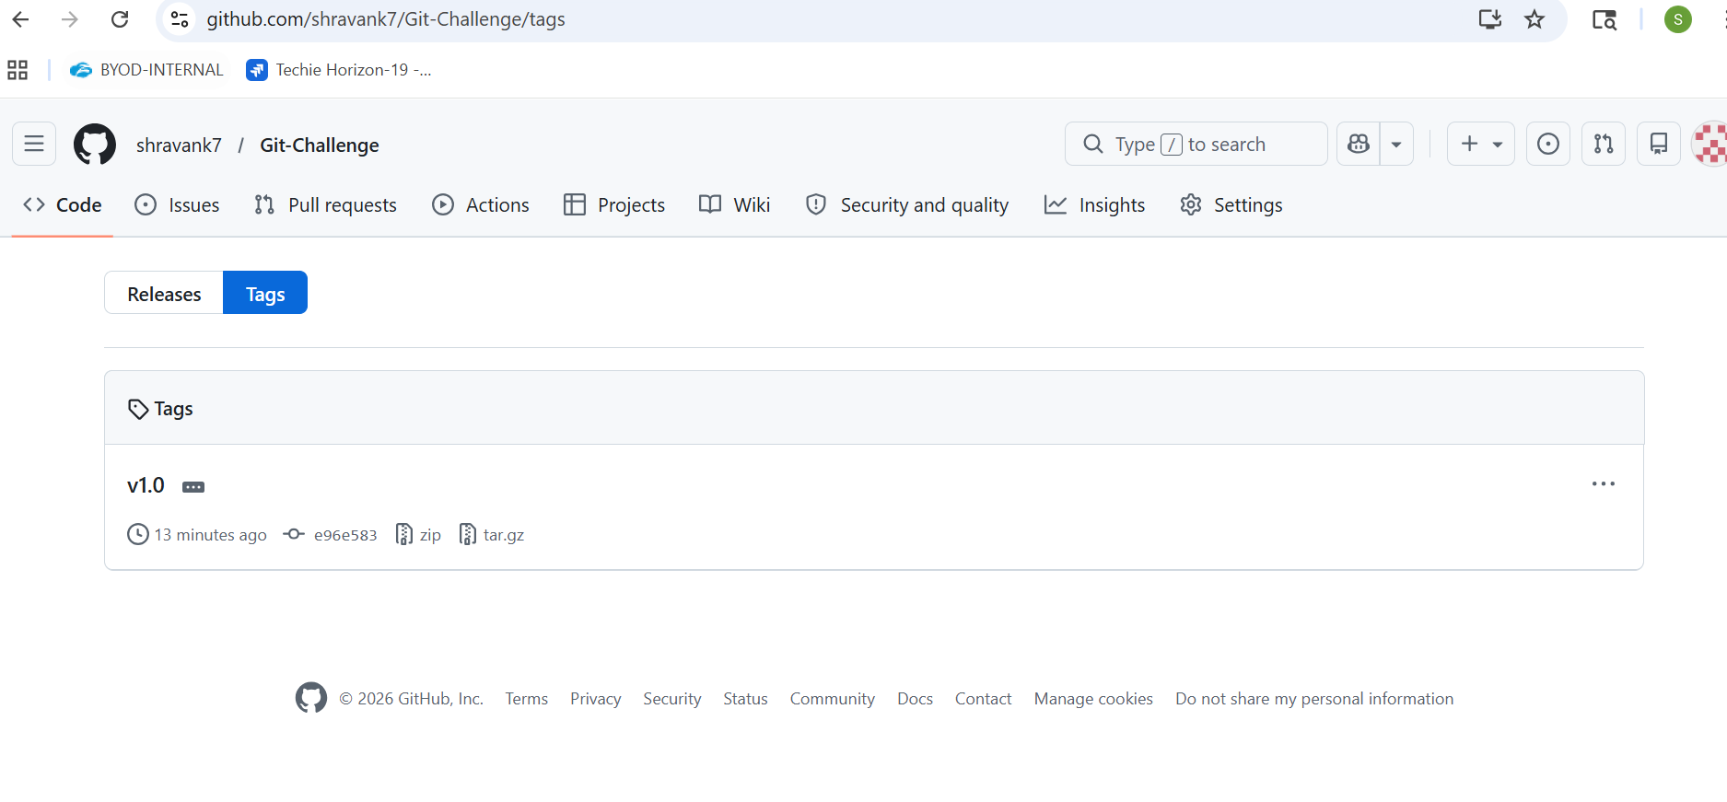
Clone with Sparse Checkout
Clone only a subdirectory of a repo using sparse checkout.
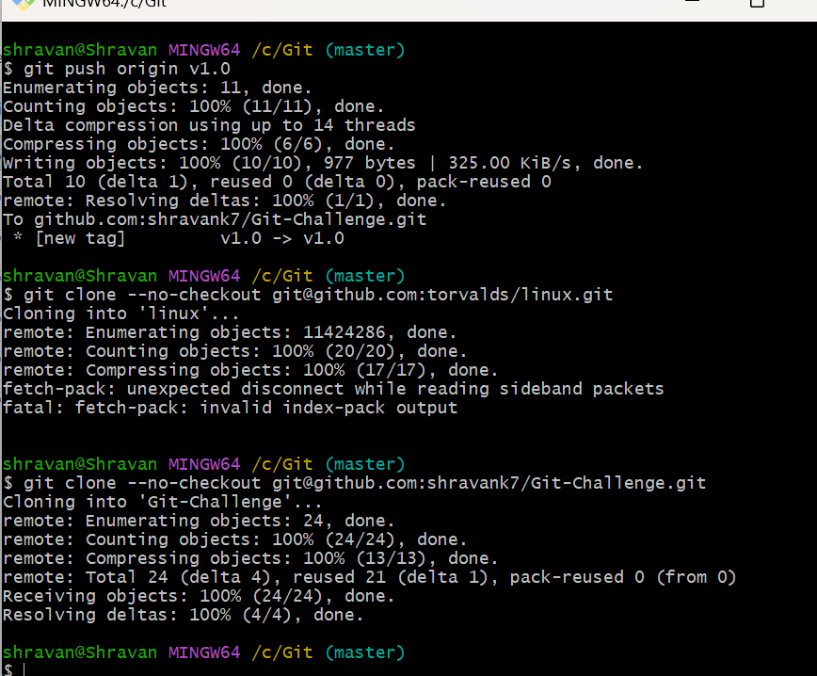
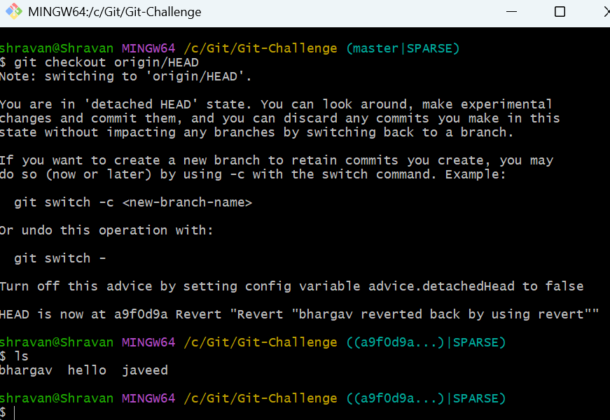
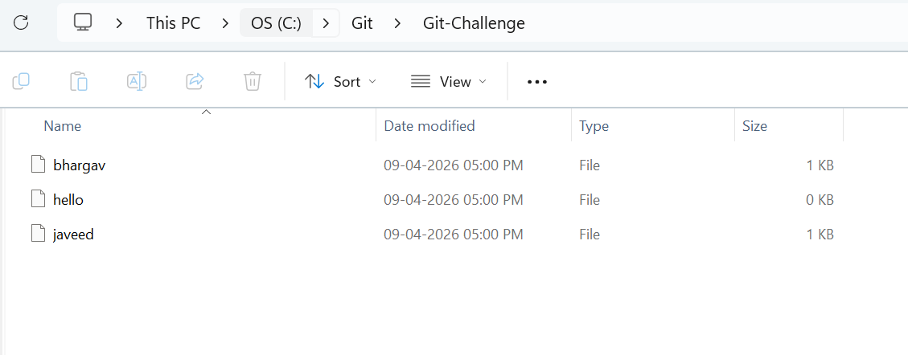
Reset vs Revert Challenge
Demonstrate the difference between git reset --hard and git revert in a repo.
git reset –hard
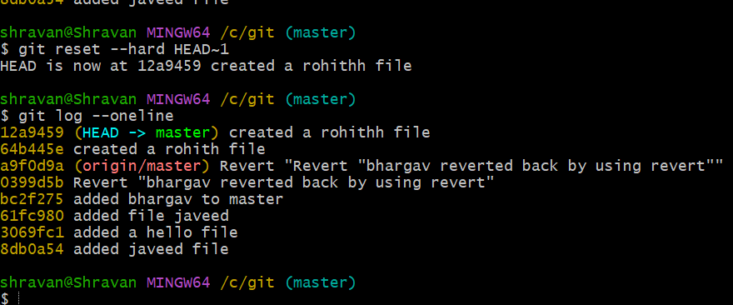
git revert
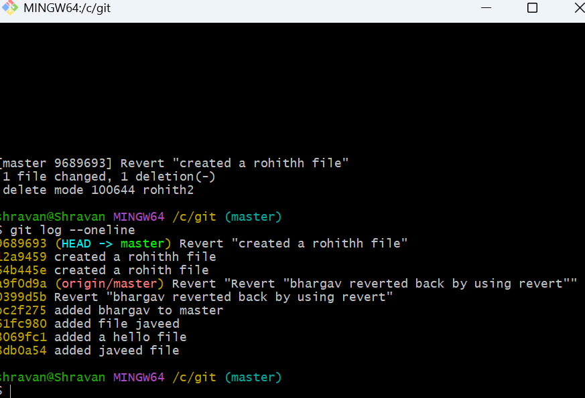
Detached HEAD Challenge
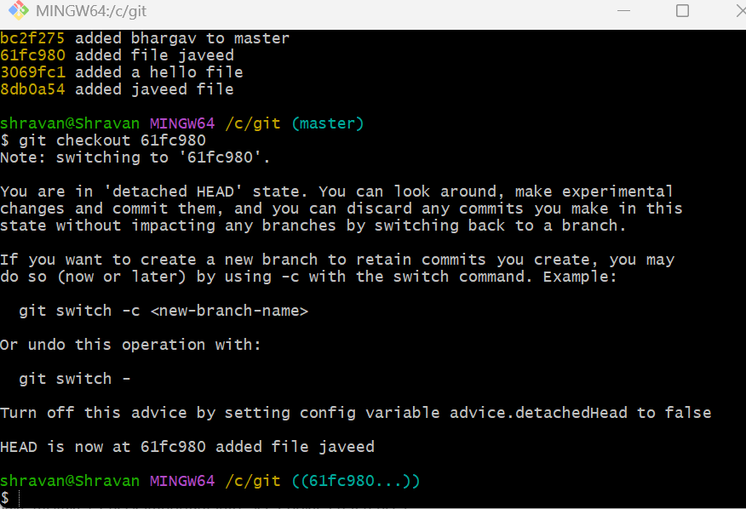
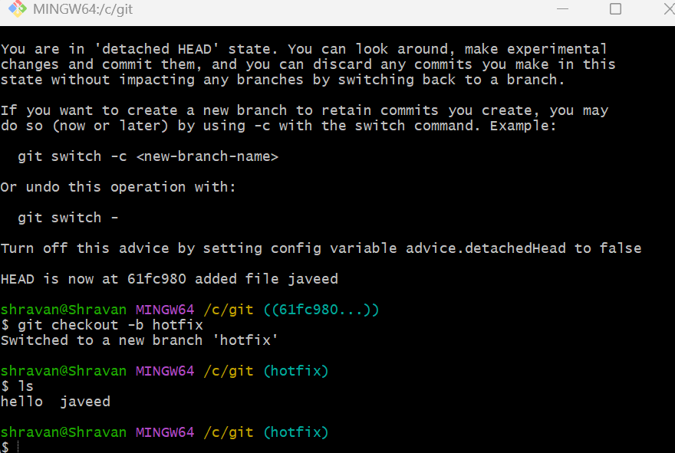
Git Hooks Challenge
- Configure a pre-commit hook to reject commits without a message format (e.g., must start with JIRA-XXX).
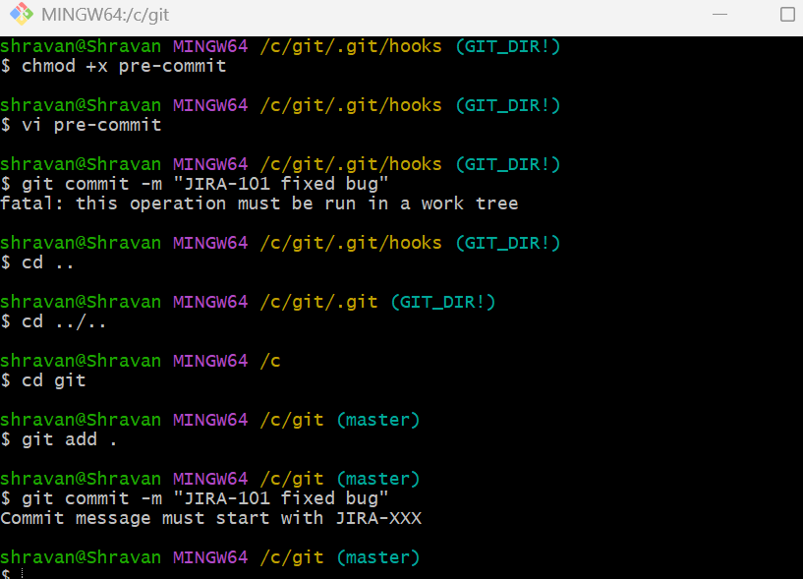
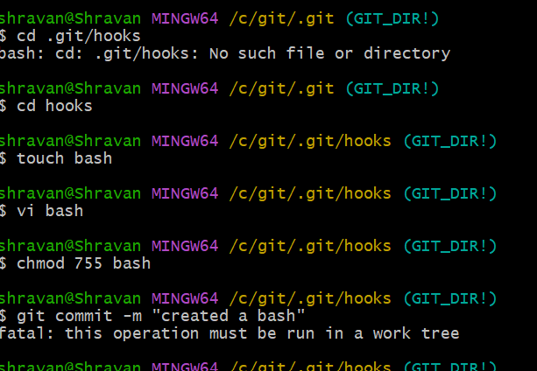
Squash Merge vs Rebase Merge


Fork & Pull Request Workflow
Fork a repo, make a change, and submit a pull request to the original repo
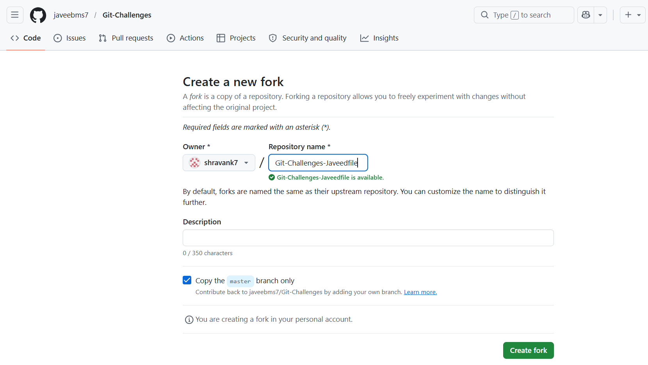
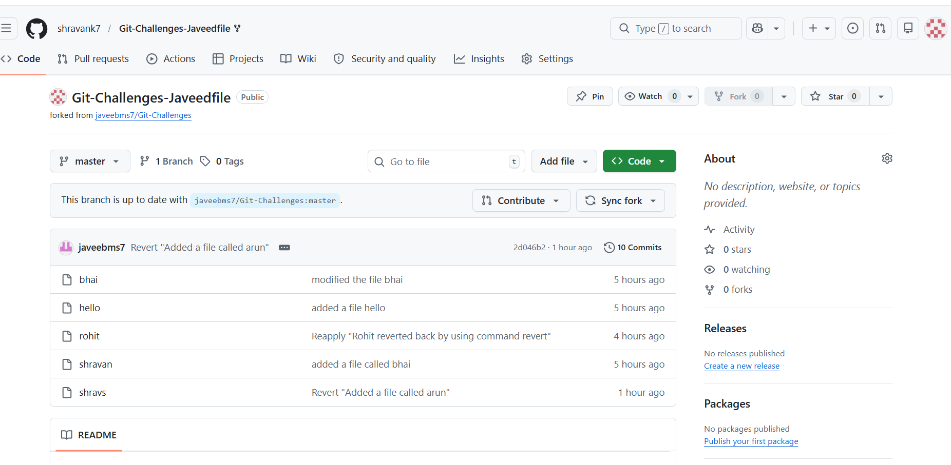
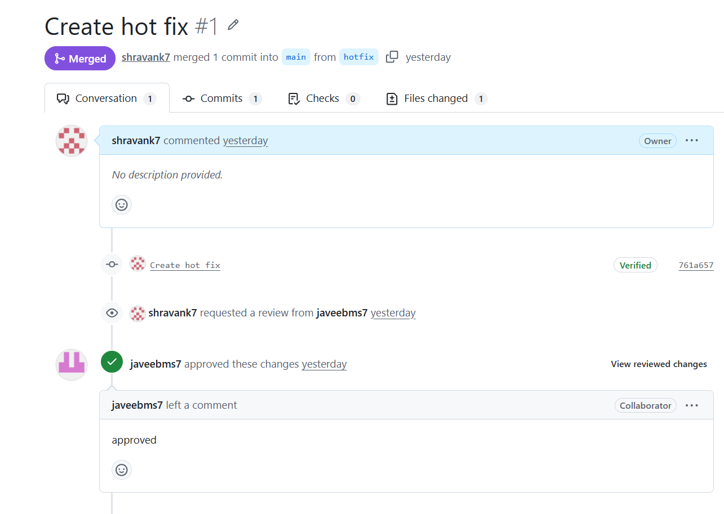
Recover Lost Commit
Commit something, reset hard, and then recover it using git reflog
